Final report Web Technology – 2ID60 – group 7

Coen de Vente, Max van Hattum, Enzo Lucas and Thijs Visser

Hosted on: restaurantwebapp.pe.hu
Video: https://www.youtube.com/watch?v=PgsykiV9Lpc

Motivation

For our final project we decided to create a web app which allows users to retrieve information of restaurants, place reviews and place orders at the queried for restaurants. We also allow restaurant owners to create a page for their own restaurant and add certain information, including a menu and on online order form. The motivation for this project came to our group while we were exploring the different functionalities API services offer. The way we see it a restaurant is basically a combination of different kinds of information. It has a place in the real world, it has a variety of foods to offer and it is a business. And it is a business that wants to attract customers and make profit. In the past, attracting potential costumers was done by word of mouth; visitors would tell their friends and family about their experience at the restaurant. But, since we now have the internet, visitors can tell of their experience at the restaurant to a much bigger audience online. Sites like Tripadvisor and Yelp offer this possibility of letting people know of your experience and it were these sites we used as inspiration. However, we wanted to extend this functionality. We also allow for user to place orders directly to the particular restaurant.
Moreover, as previously mentioned we enable restaurant owners to create a page describing their restaurant and place an online menu there.

Data

For our web app we use multiple API’s. The most important one is the Yelp API, this is used to get the information of most of the currently existing restaurants. We use 2 datasets from Yelp, one for searching restaurants in a specific location, this is the Yelp search API: http://www.yelp.com/developers/documentation/v2/search_api; the other one is the Yelp business API, this is used to get more elaborated information regarding a specific restaurant:
http://www.yelp.com/developers/documentation/v2/business.

To give a livelier feel to the restaurant pages, we also use the Flickr API to provide a picture related to the restaurant in question. Where possible, we want to use a picture of the actual restaurant, but if this is not possible we go down different alternatives, for example, we search for city or food.
https://api.flickr.com/services/rest/ .

We also use the Google Maps API and Geocoding API, which allow us to display a map with the queried restaurant in order to give a clear view of its location. Additionally, we check the user’s location with this API, which enables us to let the user decide how far away the restaurant should be from his/her current position. We also used it to place info windows at the location of the restaurant, where we can give a short overview of the restaurant in question.
Google Maps API: https://developers.google.com/maps/web/
Geocoding API by Google: https://developers.google.com/maps/documentation/geocoding/
Furthermore, we use our own user generated data set, containing user information, reviews, restaurants, menus and orders. This dataset can be found at the same location as the rest of the application.

Technical architecture

Because specific style of technical architecture was mentioned in the assignment, we have generated a table which shows how the different interfaces lock together.

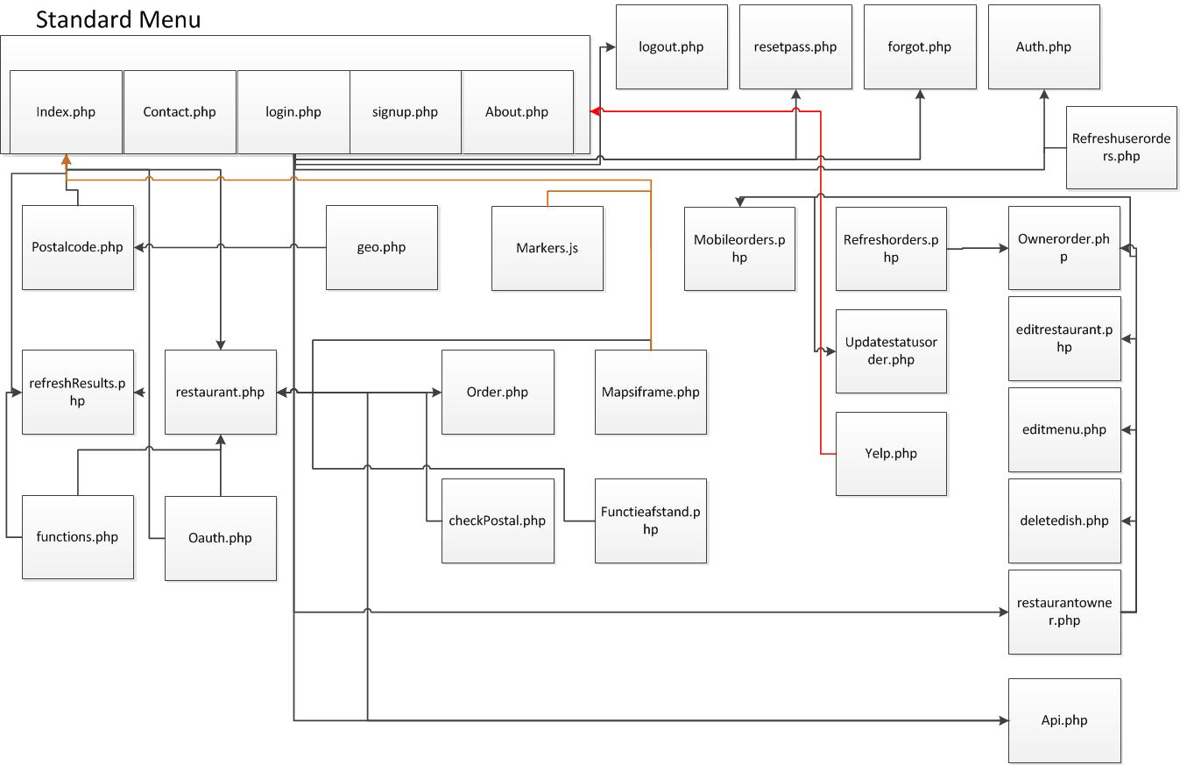
The key concept here is that there is a central menu, accessible from all pages. When you are signed in, lots of extra functions will become available. When you are on specific restaurant page, you will also be made aware of this. We kept everything a bit basic with regards to infrastructure.
The framework we use is just PHP native with a database. This database communicates with our application through MySQL. It keeps track of users, with their username, email and password (also, it harbors a function to reset your password in case you lost it); information about menu categories; orders with district ids, statuses, delivery information and payment method. Also, there is a restaurant option in which you can store basic information, specific categories of food you serve and if you deliver order and how far you do this. Our database also stores the reviews not made by yelp and associates them with a user and a timestamp. Finally, there is a dishes tab which stores information about the dishes served by a restaurant such as name, price and category.
Our own API uses the information in the database in the same way as it uses the yelp information. Moreover, there is virtually no distinction between them. The only difference is that the review from yelp and the reviews made on our site are separate. Other than that there isn’t much difference, only that our database has more additional functions, such as ordering as explained above.

User data

As mentioned a couple times before, we track the user information on several occasions. This start from the moment the user visits our site. The site lets users search by location, and is able to find the location where the user currently is. Also, we let user create an account, which offers extended functionality. A registered user can write reviews, and can become a restaurant owner and add information to his or her own restaurant page. Also, registered users are able to place orders directly to restaurants that have the option do to that.

Reflection

We believe this course has succeeded in transmitting its learning objectives. All of us have learned interesting new concepts regarding web development. Because for each team member their background knowledge was different, some of use learned more than others of course, but overall we would say it was a successful experience.
We do want to mention that in our opinion the lectures were not really contributing to our knowledge of web technology. It was moving too much matter in a too small amount of time and in the end, most of the information we needed we would find online anyway. Therefore, we would like to suggest that for this course a list of tutorials is posted online (on Sakai for example) instead of lectures and focus more on the workshops. We believe this would be more efficient and more enjoyable for the students.

As for the learning individually:
Coen: What I learned the most about during this course is probably APIs. My knowledge about this subject was basically zero. I learned some useful background information about APIs, the Internet and the World Wide Web during the lectures. I learned to make API calls through XML and JSON, using PHP. I gained knowledge about how APIs are usually built and how to use them properly. I had some experience with building websites already, when I stared with Web Technology. PHP, JavaScript, jQuery, AJAX, CSS and HTML are languages I had some experience with, already. However, also in the field of these languages, I gained quite some skills. Especially about nice functions, for example css(), setTimeOut() and on() in jQuery and urlencode() in PHP. I also learned MySQLi, after recommendation of a teammate. I also learned how to use GitHub, which turns out to be a very easy way to collaborate on a project with several people.

I would think that I am the person in the group who spent the most time on this project. At least, I had the largest contribution to it, according to https://github.com/WebTech7/RestaurantWebApp/graphs/contributors. The course has cost me more time than most other courses. I liked to follow this course and work on its projects.

I did encounter some problems along the way. The slow hosting of the website was one of the largest. It turned out that the main cause of this problem, was the MySQL database. First the database was hosted on db4free. Now it is hosted on the same server as the website. This improved the speed of the application quite a lot. It is still not the fastest website on the Internet, but that would be caused by a few problems that are not in our power to change. The pages that take long to load use two to three APIs and our own database at the same time. Thereafter, it combines the data from these APIs, which all adds up some processing time. We also uploaded the application to Heroku, but this was just as fast as our current host (hostinger.nl). Most other problems I can think of were coding problems and easily solved with a quick search on the Internet.

I have some ways to improve the course. I think some of the lectures, especially the ones in the beginning, did not have very much to do with the course, since we were not tested on the vast majority of these lectures. It is a good thing to give some background and side information, but this was maybe a bit too much. I can imagine that the tutorials on Friday and Tuesday were useful for people who had no knowledge about it, but when you already have a bit of knowledge about it, it is much too basic. It could be an idea to give some more advanced tutorials, as well. Also, I personally did not consider the lectures on Tuesday, the 3rd and 4th hour, where students were able to work on their assignments, useful, since it was always faster to look up the question on the Internet than waiting for the teachers to be done with other person’s questions. So might be a good idea to be there with more teachers. Despite these things, overall, I considered the course good and challenging enough.

Max: What I’ve learned working at this project, is to properly coordinate who codes what and to make sure everyone’s code interacts in an efficient good way.
I also had to read up a lot about php, mysqli, sql, json and xml. Since it was a long time ago that I’ve made a website. Luckily there are enough sources on the internet that explain almost everything in an understandable way. This was particularly handy for working with web API’s, since I had never done this before. Everything about php, mysqli, sql, json and xml I read about on w3schools. I find that they explain everything very clear and it is nice to see the examples and code instantly.
I also had to read up on web API’s, first I read about the difference of rest and soap (http://blog.smartbear.com/apis/understanding-soap-and-rest-basics/), after this I looked through some examples that used the openweathermap API on github and with this in the back of my mind I started trying to access API’s on my own.
On how to make my own API I found this tutorial very informational: http://www.brenelz.com/blog/how-to-create-a-simple-api-with-php-and-mysql/ . This gave me an idea on how to approach the idea of delivering data in jsonformat to developers.

Enzo: For me, it was very difficult to get this course started. I had little experience with web development so it was a lot to take in. the lectures were all a bit vague and not really useful in my opinion. I was able to get a better understanding of the subjects through online learning environments like codeacademy.com. In the end though I felt like I knew what I was doing, which is always a nice thing to realize. I believe I am now able to make a functional html site with database communication and use several API services.

Thijs:

Effort

When it comes to effort, we can honestly say we spent a lot of time on this project. Far more than the usual amount of time spent on other courses. We do have to be honest when we say that we did not contribute equally to this project, mainly because of different levels of background knowledge among team members.
The estimation of the effort of individual team members:
Coen: 40%
Max: 30%
Enzo: 20%
Thijs: 10%

However, this estimation is mostly based on results delivered, and not so much on time spent on the assignment, because for some this assignment was more challenging than for others.

Coen really was the driving force behind this project. Having had a decent amount of experience in web development, Coen was able to quickly state what was required and also able to implement this. This is why he has the largest amount of work contributed in this project. Also, Coen refers to himself as a perfectionist, which meant that there was according to him always a point of improvement within our web app.
Max was Coen his right-hand man, providing the whole team with additional support. He too had a bit of experience with web development, and was therefore easily able to fix problems. Coen and Max both contributed a lot to this project. But because the main ideas usually came from Coen his share is higher.
Enzo did not have a lot of experience with web development, but had practiced it a bit during secondary school. It was because of this that his share was not that influential, because anything he did, Coen and Max were able to do faster (and usually better). In the beginning he was really involved with the project, but his attention wavered at the end.
Thijs had a bit of a slow start with this project. He had even less experience than Enzo so it was very hard for him to catch up with the others. Because Thijs had neglected to review his mail in the beginning of this quartile, making communication difficult. When this all was sorted out however, he tried to help whenever he could.

Improvements after feedback

Of course we took the feedback to heart and looked for ways to improve our application. We basically improved some minor aspects, such as a better distance related search, but our main focus point was the ordering part of our own web API, since this was the main point of concern.

Our own API is an application which is able to allow users to create an account and store reviews for restaurants made by the users as previously described. The additional focus is now that when you login you can claim ownership of a restaurant. When you do this you can control a variety of factors. Of course you can alter the basic information as stated before but you can also allow user to make orders directly to you by using our site. The process works as follows: you set your restaurant to accept orders. After this, you can add dishes to your restaurant. These dishes are specified by name, category, description and price. For example, a pizza Quattro fromagi, Italian, pizza with 4 cheeses, 2.00. This places the dish on your unique restaurant page. Users then can visit your unique restaurant page and select this pizza from the menu. The user fills in his postal code and our app checks if the given postal code is not too far away. If it is not, the user needs to fill in additional information and after that the order is complete. The restaurant owner then has a special page where he can see all the orders places and the information of the customer. He then has the ability to assign statuses to the orders such as: delivered, preparing or on the way. The users can keep track of this status by clicking the icon next to his name.
It is in this way we have improved our order service.
Also a smaller update is the ability to link your restaurant on our site to your restaurant on the yelp site.

As stated on the feedback, our web app was a bit slow. This was due to our hosting. We moved our application to heroku but the performance didn’t chance noticeably. You can verify this at: http://agile-headland-6568.herokuapp.com/postalcode.php . In order to increase performance we did chance the location of the database. This was first hosted on db4free.net, but was transferred to the same server as the rest of the application. This did improve the performance.

